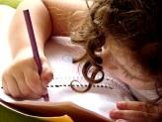  Literacy  In Literacy we will be following our Talk 4 Writing scheme. Our first unit involves a fiction journey tale about a papaya that spoke. We will then look The Framer’s diary entries to write our diary entry in the second half of our half term. | 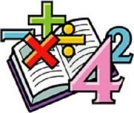  Maths  In Math, Year 2 will start by learning about 2D and 3D shapes, their properties and how to draw 2D shapes. We will then move on to learning about money and length and height.  In math, Year 1 will be learning about addition and subtraction. We will explore parts and wholes, number bonds within 10 and subtraction on a number line. | 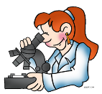  Science  We are learning about the use of everyday materials including wood, metal, plastic, glass, brick, paper and cardboard. We will be focussing on how to perform simple tests so that we are able to choose materials suitable for a particular purpose. | 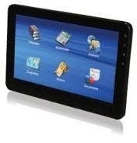  Computing  This half term, we will be learning all about algorithms and debugging. We will start by exploring algorithms and how they are used. Towards the end of the half term, we will learn what abstraction and debugging is.
Humanities  In Geography, Year 2 will be looking at the 7 continents and the 5 Oceans. We will use maps, atlas’ and globes to identify and locate these.  In Geography, Year 1 will be looking at ‘Where we live’. This will include, identifying then town that we live in and finding out our postcards. We will also look at different types of houses and how to draw an aerial map. | 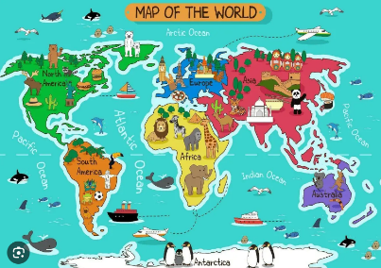  Year 1/2B Curriculum Map  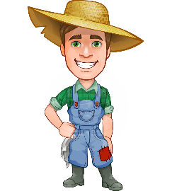  Overdale Community Primary School  Autumn Term 2 2023 |  | 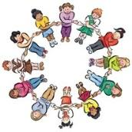  PHSCE In PHSE and RSE we will continue developing our knowledge and skills surrounding health and wellbeing. This will include looking at different emotions, being active and developing a growth mindset. Towards the end of the half term, we will look at the importance of a healthy diet and how to look after our teeth.
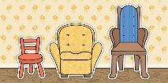  DT  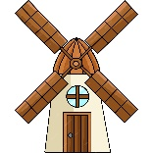  In DT, we will be looking at structures. We will focus on designing, creating and evaluating our structures. Year 2 will be creating a chair for Baby Bear and Year 1 will be creating a windmill. | 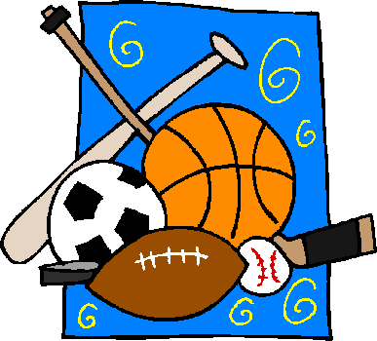  PE  In P.E, our focus will be on gymnastics. Throughout the half term, we will look at curled positions and how we can travel in this position, stretches and creating sequences to showcase our movements. | Music In music we will explore animals through African call and response song. We will be learning a traditional song from Ghana and how to create rhythms. | RE In RE we will be thinking about ‘How and why do we celebrate special times?’ Our focus will be on what Christians, Muslims and Jewish people celebrate and how.
Reading: Children will be expected to read their home reading books three times a week with a written comment from a parent in their reading record. Children will also have access to their class Lending Library where they can bring home alternative books to read for pleasure with an adult. Some children may also start to bring home stretch and challenge books to accompany their weekly reading sessions.
Maths: To complement our learning we will be looking at the 10, 2, 5 and 3 times tables. Any help at home wit this would be greatly appreciated – thank you
Homework: Your child will continue to use their homework book. Inside the homework book is a ‘Menu’ of activities should you wish to complete. These activities are optional but do complement our learning in school.
Useful websites: https://numbots.com/ - your child has a log in for numbots https://www.bbc.co.uk/teach/supermovers/times-table-collection/z4vv6v4 - free resource
https://ttrockstars.com/ - your child has a log in for TT Rockstars Collins Ebooks (collinsopenpage.com) - your child has a log in for this

